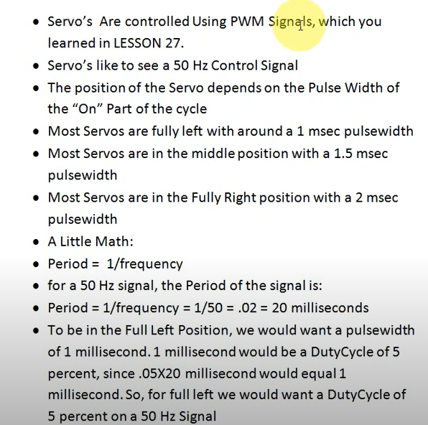

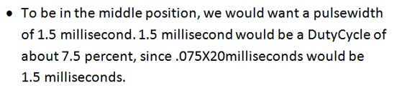

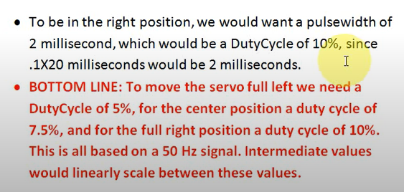

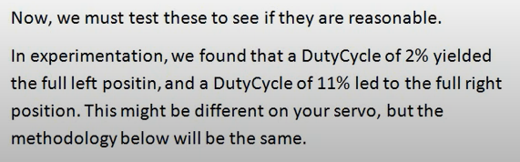

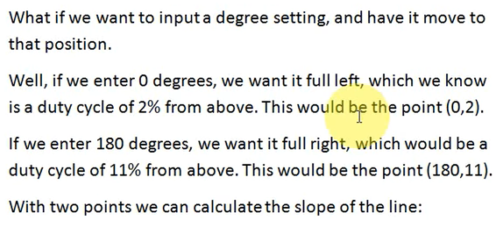

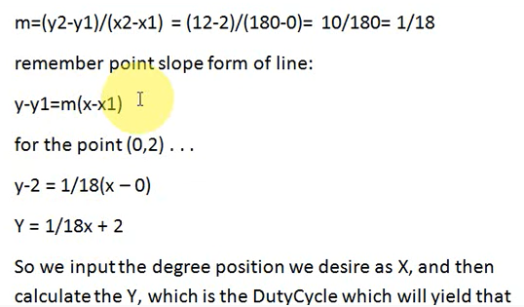

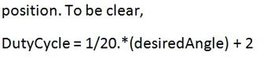

**DutyCycle = 1/18 * (desiredAngle) + 2**

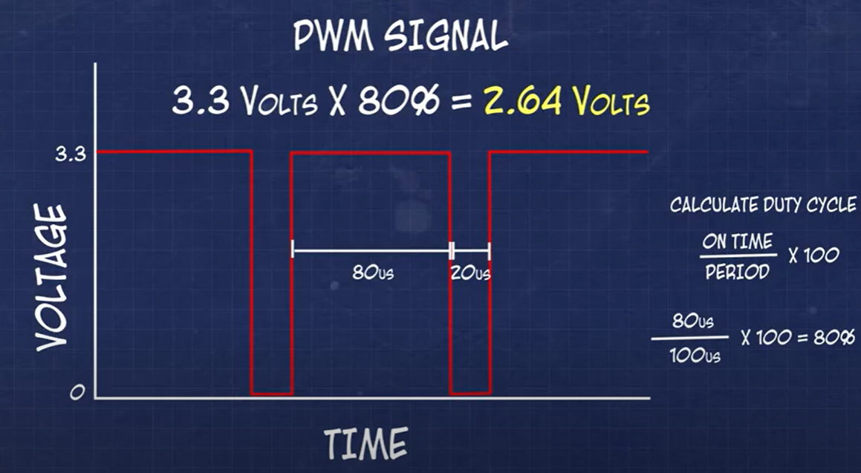

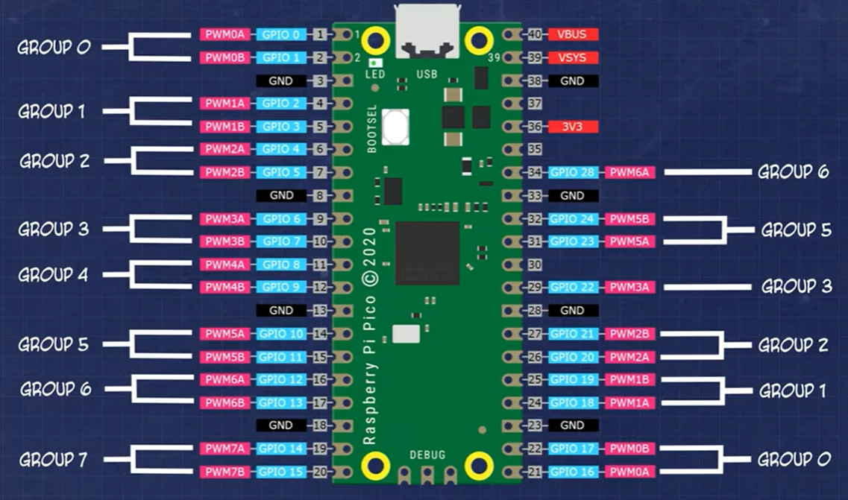

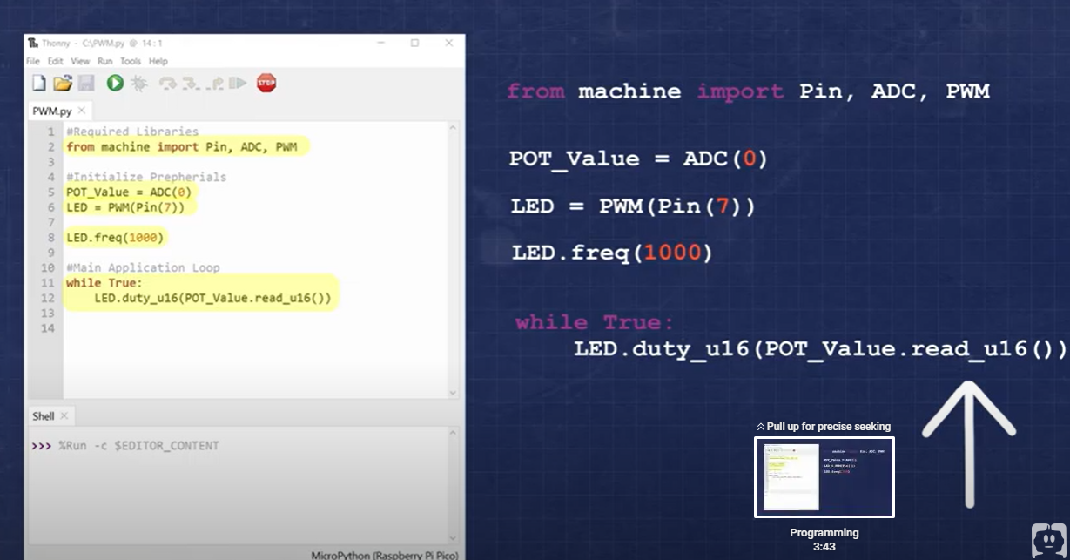

**1000 hertz or 1 kHz is above threshold of what the human eye can see in a flashing LED**

**POT_Value.read_u16 is the reading from the Analog pin which is 0 to 65535 (0 to 3.3V)**

**LED.duty_u16 converts the reading from the Analog pin to the voltage from the pin, which determines the brightness of the LED. 0 is off and 3.3 is brightest.**

**A potentiometer / an LDR / can vary the reading from the Analog Pin**